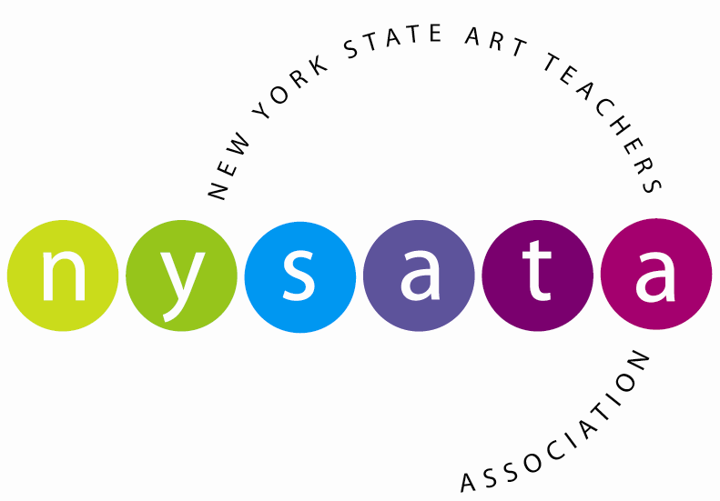

Executive Officers
President
Thomas Knab
President Elect
Robert Wood
Vice President
Cindy Henry
Secretary
Amanda Buhler
Treasurer
Jane Berzner

Region Representatives
Region 1
Michelle Schroeder
Sarah Qureshi
Region 2
Dr. Karen Trickey
Valerie Savage
Region 3
Michele Gorham
Donnalyn Shuster
Region 4
Jill Karen Accordino
Geraldine Link
Region 5
Shannon Piché-Smith
Terry Crowningshield
Region 6
Phyllis Brown
Kathleen Bushek
Region 7
Sharon Ciccone
Martin Merchant
Region 8
Joan Davidson
Dr. Anu Androneth Sieunarine
Region 9
Jessica Bayer
Regina Russo
Region 10
Cheryl Schweider
Loretta Corbisieroe
Accounts Receivable
Membership
Conf. Registrar
Terri Konu
Financial Advisor
Leslie Midgley
NYSATA News
Beth Thomas
Web Site/Communications
Cindy Henry
Annual Conf. Coordinators
Pat Groves
Cynthia Wells
Annual Conf. Business Mgr.
Jessica Bayer

www.nysata.org

September 1, 2014

Dear School Administrator,

We are please to announce the 66th annual New York State Art Teachers Association Conference will be held November 21 – 23, 2014 at the Desmond Hotel & Conference Center in Albany, NY. The annual conference draws over 600 professionals representing art educators, higher education, museum educators and commercial vendors. It provides the largest and most diverse professional development opportunities available to New York State Art Educators.

This year’s conference STAND UP for Art Education will explore the powerful role art education plays in developing the full potential of all students. Art making pulls together ideas from many disciplines; transforms then into new ideas through multi-layered approaches and processes. The current research in learning and brain development continues to emphasize creative thinking, critical thinking and the self-discipline to work both collaborative and independent settings. These skills are deeply embedded in the teaching and making of art.

Conference opportunities include over ninety workshops, and four general sessions that provide interactive learning through hands-on engagement and introduce the most current technologies, art curriculum and standards, assessments and advocacy material available. All program events focus on high quality art education content that can be applied immediately to teaching and learning. This year’s General Sessions include American Sculptor Charles Simonds, author and professional arts advocate Bruce Taylor, “artist-teacher-visual cultural researcher-digital media flaneur-novice hacker and pixel stacker” Dr. Aaron Knochel and the collaborative artist team Forceperunit.

In this era of high stakes testing, we know the arts are critically important in developing human potential in our students. I ask your encouragement and support for your art educators in advancing their knowledge and professional skills, by providing release time for their participation and support for conference registration, travel and lodging.

Further information about STANDUP for Art Education and other programs is available at www.nysata.org.

NYSATA looks forward to providing your art educators a valuable and timely professional experience.

Thank you for your leadership as we work toward ensuring a total quality education for all students.

Sincerely,

Thomas Knab
President, New York State Art Teachers Association

